**Create a Chatbot using Python**

|  |  |
| --- | --- |
| **Date** | **10-09-2023** |
| **Team ID** | **3918** |
| **Project Name** | **Create a Chatbot using Python** |

**Table of Contents**

|  |  |
| --- | --- |
| 1 | Introduction |
| 2 | Problem Statement |
| 3 | Design and Innovation Strategies |
| 3.1 | User-Centered Design |
| 3.2 | Conversational Design |
| 3.3 | Personalization |
| 3.4 | Advanced Natural Language  Processing (NLP) |
| 3.5 | Machine Learning for Intent Recognition |
| 3.6 | Ethical Considerations |
| 4 | Conclusion |

**1. Introduction**

Chatbots are AI-powered conversational agents that interact with users through text, voice, or other modalities. To be successful, chatbots must offer a seamless user experience and provide valuable interactions. Innovative design strategies and the integration of advanced technologies are fundamental to achieving these goals.

**2. Problem Statement**

Artificial intelligence chatbot is a technology that makes interactions between man and machines using natural language possible. A chatbot can give different responses from the same input given by the user according to the current conversation issue". By using our "Intelligent ChatBot" you can overcome all the above-given issues, you do not need humans to do manual work, your clients will be happy.A chatbot is a conventional agent that is capable to communicate with operators by using natural languages. As numerous chatbot platforms already exist, there are still some problems in building data-driven system because a huge amount of data is required for their development.

**3. Design and Innovation Strategies**

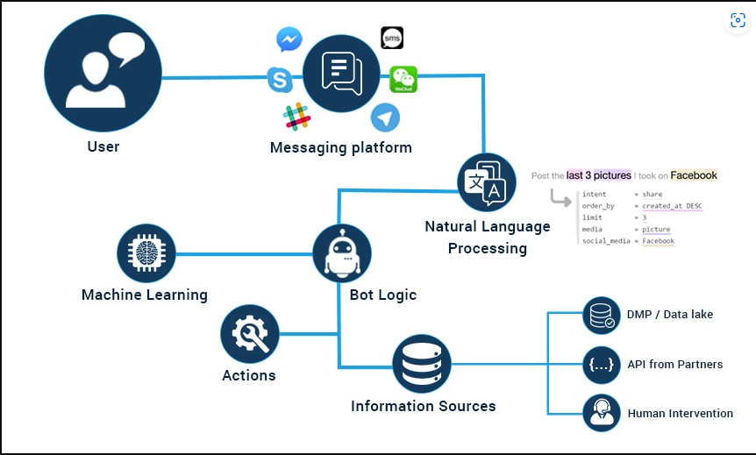

**3.1. User-Centered Design:**

Clearly outline the specific use cases and objectives for your chatbot. Identify areas where GPT-3's language understanding capabilities can significantly enhance the quality of responses.

Incorporate GPT-3 into your Natural Language Processing (NLP) pipeline. Develop a seamless integration that allows the chatbot to leverage GPT-3 for understanding user inputs and generating responses.Explore options for fine-tuning GPT-3 on domain-specific data relevant to your chatbot’.

**3.2. Conversational Design:**

Conversational flows can now be more dynamic and adaptable, as GPT-3 enables chatbots to handle a broader range of user inputs. This dynamic responsiveness enhances user engagement and satisfaction by creating a more fluid and natural conversation. Moreover, GPT-3's capacity to generate coherent and contextually relevant responses across multiple turns in a conversation allows for the development of chatbots that excel in sustained interactions, mimicking the fluidity of human conversations.

**3.3**  **Personalization:**

Personalization in conversational design, when coupled with advanced techniques such as leveraging pre-trained language models like GPT-3, becomes a powerful strategy to significantly enhance the quality of responses and create a more engaging user experience. Personalization involves tailoring interactions to meet individual user preferences, making the conversation feel more relevant and meaningful.

**3.4. Advanced Natural Language Processing (NLP):**

Exploring advanced natural language processing (NLP) techniques, especially with pre-trained language models like GPT-3, can significantly elevate the quality of responses in a chatbot. Here are key areas where advanced NLP plays a crucial role:

1. **Contextual Understanding:**

Leverage pre-trained language models like GPT-3 for enhanced contextual understanding. These models excel in grasping the context of a conversation, allowing the chatbot to generate responses that are contextually relevant and coherent.

1. **Semantic Analysis:**

Apply advanced semantic analysis techniques to go beyond simple keyword matching. GPT-3, with its deep learning capabilities, can understand the meaning and intent behind user queries, leading to more accurate and insightful responses.

**3.5. Machine Learning for Intent Recognition**

It referring to recognizing information or entities from internet sources, including text data, machine learning techniques, and pre-trained language models like GPT-3 can be highly beneficial. Let's explore how advanced machine learning can enhance information recognition.

1. **Web Scraping and Data Collection:**

Utilize machine learning algorithms to automate web scraping and collect relevant information from various internet sources. GPT-3 can assist in understanding and extracting information from unstructured text data.

1. **Named Entity Recognition (NER):**

Implement NER models to identify and categorize entities (such as names, locations, organizations) in internet text data. GPT-3 can contribute to improving the accuracy and depth of entity recognition.

**3.6**  **Ethical Considerations:**

Here are key ethical considerations when enhancing the quality of responses using these advanced techniques:

1. Bias and Fairness:

Pre-trained language models may inadvertently perpetuate biases present in their training data. It's crucial to assess and mitigate biases to ensure fair and equitable treatment of all users, regardless of factors like race, gender, or ethnicity.

1. Transparency:

GPT-3 and similar models are complex, and their decision-making processes can be opaque. Ensuring transparency in how the model operates, and in the decisions it makes, is important for building trust with users.

1. **User Privacy:**

Handling user data with utmost care is paramount. Clearly communicate how user data is used, stored, and processed. Implement robust security measures to safeguard sensitive information and adhere to relevant data protection regulations.

**4. Conclusion :**

In conclusion, the exploration of advanced techniques, notably leveraging pre-trained language models like GPT-3, offers a transformative avenue for enhancing the quality of responses in various applications, particularly in the realm of conversational AI. The capability of these models to comprehend context, discern nuanced language, and generate human-like responses represents a significant leap forward in natural language processing. By integrating such advanced techniques, developers can craft chatbots and conversational agents that exhibit a level of sophistication, adaptability, and responsiveness that was once beyond reach.

The journey toward utilizing pre-trained language models involves a careful orchestration of design, innovation, and ethical considerations. Design strategies focusing on conversational flows, user personalization, and dynamic adaptation enable the creation of chatbots that not only understand user intent but also engage in meaningful and context-aware conversations.